
Islamia University of Bahawalpur

Fake News Detection System

A project presented to
Department of Computer Science, IUB

In partial fulfillment
of the requirement for the degree of

Bachelor of Science in Computer Science (2021-2025)

By

Wafa Abbas
F22BSEEN1E02096
Fall 2022 – 2026

Declaration
We hereby declare that this software, neither whole nor as a part has been copied out from any source. It is further declared that we have developed this software and accompanied report entirely on the basis of our personal efforts. If any part of this project is proved to be copied out from any source or found to be reproduction of some other. We will stand by the consequences. No Portion of the work presented has been submitted of any application for any other degree or qualification of this or any other university or institute of learning.

Student Name: Wafa Abbas

CERTIFICATE OF APPROVAL

It is to certify that the final year project of BS (CS) “Online Grocery Delivery App” was developed by Wafa Abbas, F22BSEEN1E02096, Fall 2022-2026 under the supervision of “Mam RUBAB SHEIKH” and that in her opinion, it is fully adequate, in scope and quality for the degree of Bachelors of Science in Computer Science.

Supervisor

External Examiner

Chairman Department of Computer Science

Acknowledgement
I extend my heartfelt gratitude to my supervisor, Mam RUBAB SHEIKH, for her invaluable guidance, support, and encouragement throughout this project. I am also deeply grateful to my family and friends for their unwavering support and motivation.

Abbreviations
Provide a list of all abbreviation used in the document.

SRS | Software Require Specification
SDD | Software Design Description
HTML | Hypertext Markup Language.
CSS | Cascading Style Sheets
PC | Personal Computer

Table of Contents
- Introduction 1
  - Brief 1
  - Relevance to Course Modules 1
  - Project Background 1
  - Related Material and Literature 2
  - Analysis from Literature Review (in the context of your project) 2
  - Methodology and Software Lifecycle for This Project 2
    - Rationale behind Selected Methodology 2
- Problem Definition 4
  - Problem Statement 4
  - Deliverables and Development Requirements 4
  - Current System 5
- Requirement Analysis 2
  - Use Cases Diagram 6
  - Functional Requirements 4
  - Non-Functional Requirements 4
- Design and Architecture 5
  - System Architecture 5
  - Data Representation [Diagram + Description] 6
  - Process Flow/Representation 6
- Implementation 11
  - Algorithm 11
  - External APIs 11
  - User Interface 12
- Testing and Evaluation 17
  - Manual Testing 17
    - System testing 17
    - Unit Testing 17
    - Functional Testing 17
    - Integration Testing 17
  - Automated Testing: 22
- Conclusion and Future Work 22
  - Conclusion 22
  - Future Work 22
References 23

Introduction
Online Grocery Delivery App is a web-based e-commerce platform designed to provide users with a smooth and efficient online shopping experience. This system allows customers to browse a wide range of products, view detailed product information, add items to their cart, and place orders conveniently. It supports both administrative features, such as product management, user management, order management and customer features, including account registration, product searching, add items to cart and secure checkout. The goal of this project is to develop a user- friendly and responsive online store that enables easy buying and selling of goods, ultimately enhancing accessibility and comfort in shopping. The system also aims to simplify business operations for sellers by providing a centralized platform to manage their inventory and customer interactions.

Brief
This e-commerce platform allows users to buy a variety of products through a user-friendly online interface. Customers can browse items, add them to their cart, and place orders efficiently, while administrators can manage products, categories, and orders through a secure backend. The project is built using HTML, CSS, Bootstrap, PHP, and MySQL, following the Agile methodology to ensure flexible and continuous development. The system aims to streamline the shopping experience for users and simplify business management for store administrators.

Relevance to Course Modules
The project applies concepts from Web Development, Database Management, Object-Oriented Programming, and Software Engineering.

Project Background

Inspired by the growing demand for convenient and accessible online shopping, this project addresses the need for a user-friendly e-commerce platform where users can easily purchase products from the comfort of their homes. It aims to simplify the buying process for customers and provide sellers with an efficient way to manage their inventory and sales. The project promotes digital commerce by bridging the gap between traditional shopping and modern technology-driven solutions.
1

Related Material and Literature
Current e-commerce platforms like Daraz, and Shopify focus on providing a smooth and fast retail experience for users. Similarly, this project draws inspiration from such platforms but is designed as a simplified and customized solution for small-scale sellers and buyers seeking a local online shopping experience.

Analysis from Literature Review
Compared to large-scale commercial platforms, this Online Grocery Delivery App project focuses on usability, simplicity, and accessibility for both customers and administrators. The system is developed to fulfill the essential needs of an e-commerce platform without unnecessary complexity, making it ideal for small businesses or startups.

Methodology and Software Lifecycle for This Project
Agile methodology was selected due to its iterative approach, allowing for continuous feedback and improvements.

Rationale behind Selected Methodology

The Agile methodology was chosen because of its iterative and flexible approach, which allows for continuous feedback from stakeholders and the incorporation of new requirements during development. It aligns well with the dynamic nature of e-commerce projects, ensuring timely delivery of functional increments, such as user registration, product browsing, and payment processing.
Review Plan

Deploy Design

Test Develop

Figure1.6.1: Agile Methodolog

Problem Definition

Problem Statement
The absence of localized and user-friendly online platforms for general product shopping often limits both buyers and sellers, especially small businesses and individual users. Many existing platforms are either too complex or not tailored to local needs, making online selling and purchasing difficult for non-technical users.
Online Grocery Delivery App addresses these challenges by offering a simple, accessible, and dedicated e- commerce platform. It enables users to browse products, place orders, and manage sales with ease. The system supports small sellers in reaching customers online and promotes digital trade by simplifying shopping and selling processes for everyday users.

Deliverables and Development Requirements

Deliverables

- A fully functional web application that enables users to browse and buy items.

- Secure user registration and authentication system.

- Admin dashboard for managing users, products, and transactions.

- Features for listing items, browsing available items, and completing purchases.

- Payment processing system with support for multiple payment methods.

- A user-friendly interface for both desktop and mobile platforms.

Development Requirements

- Hardware Requirements: The application requires devices with at least 2GB of RAM, a 500GB HDD, and an Intel i5 processor for optimal performance.
- Software Requirements: Development tools include XAMPP Server, and Visual Studio.
- Functional Requirements: These include user authentication, product management, and transaction handling.
- Non-Functional Requirements: Emphasis on security, performance, availability, and usability to ensure a seamless user experience.

Current System

In the current scenario, most people rely on either physical retail stores or generic online platforms to purchase products. However, these traditional systems face multiple limitations, especially for users who seek convenience, variety, and streamlined purchasing experience
Current limitations include:

- Limited Accessibility: Physical stores require customers to visit in person, which limits convenience and access, especially for those in remote areas or with busy schedules.
- Fragmented Shopping Experience: Many local businesses do not have an online presence, and available online stores often lack proper categorization, filtering, and search capabilities, making product discovery time-consuming.
- Lack of Centralized Management: Small-scale sellers often struggle with managing inventory, orders, and customer interactions due to the absence of an integrated digital solution.
- No Personalization or Analytics: Traditional systems rarely use customer data to offer personalized recommendations or optimize the shopping experience.
The Online Grocery Delivery App project overcomes these shortcomings by offering a comprehensive web- based platform that enables customers to browse, search, purchase, and orders for various product categories. The system includes admin and panels to manage products, users, and transactions efficiently, creating a seamless and scalable e-commerce environment.

Requirement Analysis

Requirement analysis (also known as requirements gathering or requirements specification) is the process of identifying, understanding, and documenting the needs and expectations of the stakeholders for a specific system, product, or service. The goal is to create a clear and detailed understanding of what the system must do, how it should behave, and any constraints or limitations it must operate within.

Use Cases Diagram

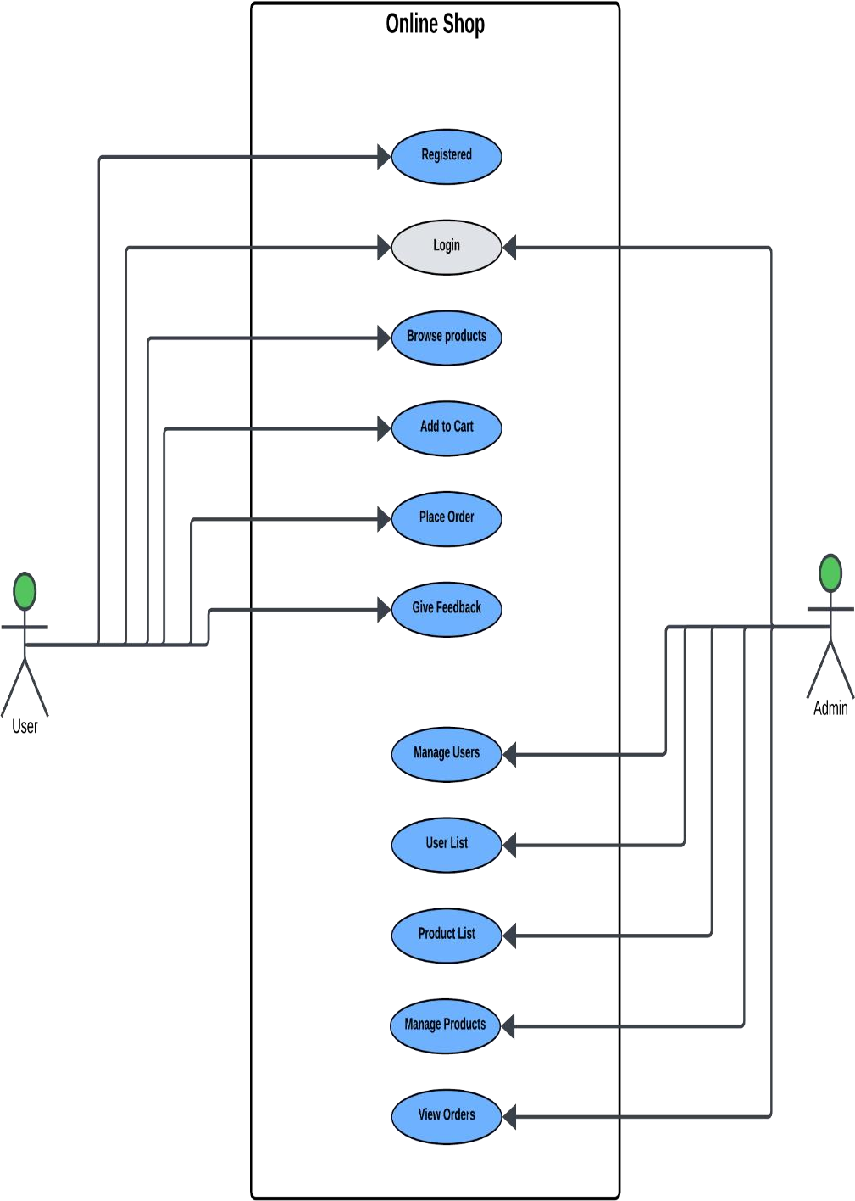

Figure3.1 Use case diagram of System

Use case description
The following tables provide detailed descriptions of the use cases identified for the Online Grocery Delivery App. Each use case describes a specific interaction between a user (or actor) and the system, outlining the steps involved in completing a task or achieving a goal. These use case descriptions help in understanding the system's functionality and the requirements for different user roles, including guest users, registered users, and administrators. By documenting these use cases, we ensure that all possible scenarios are considered during the design and development phases, ultimately leading to a more robust and user-friendly system.

Table 3.2.1: User Registration

Use Case ID: | UC-1
Use Case Name: | Register an Account
Actors: | Primary Actor: User
Description | User registers to create an account on the platform.
Trigger | User clicks “Register”.
Preconditions | None.
Postconditions | User account created successfully.
Normal Flow | - User clicks "Register".  - User fills out the registration form.  - System validates and saves user information.  - Confirmation sent.
Alternative Flow | Invalid input data. User cancels.
Exceptions | System provides error feedback for invalid data.
Business Rules | Registration must be secure.
Assumptions | Users will provide correct details.

Table 3.2.2: Login

Use Case ID: | UC-2
Use Case Name: | Login
Actors: | Primary: User
Description | User logs into their account to access personalized features.
Trigger | User clicks "Login".
Preconditions | User account exits.
Postconditions | User authenticated successfully.
Normal Flow | - User clicks "Login".  - User enters credentials.  - System authenticates and redirects to the main page.  - User gains access.
Alternative Flow | Incorrect credentials.  User cancels.
Exceptions | System prompts for reattempt.
Business Rules | Authentication must be secure.
Assumptions | Users provide valid credentials.

Table 3.2.3: Browse Products

Use Case ID: | UC-3
Use Case Name: | Browse Products
Actors: | Primary: User
Description | User browses product categories and views product details.
Trigger | User selects a category.
Preconditions | None.
Postconditions | Products displayed based on the category.
Normal Flow | - User selects a category.  - System displays products in the category.  - User views details of specific products.
Alternative Flow | No products available in category.
Exceptions | System informs the user.
Business Rules | Categories are pre-defined.
Assumptions | Products are updated regularly.

Table 3.2.4: Add to Cart

Use Case ID: | UC-4
Use Case Name: | Add to Cart
Actors: | Primary: User
Description | User adds selected products to their shopping cart.
Trigger | User clicks "Add to Cart".
Preconditions | User must be logged in.
Postconditions | Product added to the cart successfully.
Normal Flow | - User selects a product.  - User clicks "Add to Cart".  - System adds product to the cart and updates cart details.
Alternative Flow | Product out of stock.
Exceptions | System informs the user.
Business Rules | Stock levels are monitored
Assumptions | Users will check stock availability.

Table 3.2.5: Place Order

Use Case ID: | UC-5
Use Case Name: | Place Order
Actors: | Primary: User
Description | User places an order for products in their cart.
Trigger | User clicks "Place Order".
Preconditions | User must have products in the cart.
Postconditions | Order placed and confirmed.
Normal Flow | - User clicks "Place Order".  - System verifies cart and user details.  - User provides delivery details and payment method.  - Order processed and confirmation sent.
Alternative Flow | Payment failure.  User cancels order.
Exceptions | System informs the user and allows retry or cancelation
Business Rules | Transactions are secure.

Assumptions | Users are likely to proceed with valid payments.

Table 3.2.6: Give Feedback

Use Case ID: | UC-6
Use Case Name: | Give Feedback
Actors: | Primary: User
Description | User provides feedback or reviews for a product or order.
Trigger | User navigates to "Feedback".
Preconditions | User must be logged in.
Postconditions | Feedback saved and acknowledged.
Normal Flow | - User navigates to “Feedback”.  - User fill out the feedback.  - System saves and confirms feedback submission.
Alternative Flow | Feedback not submitted.
Exceptions | System allows re-entry.
Business Rules | Feedback is stored securely.
Assumptions | User will provide genuine feedback.

Table 3.2.7: Manage Users (Admin)

Use Case ID: | UC-7
Use Case Name: | Manage users.
Actors: | Primary: Admin
Description | Admin manages user accounts, including adding, updating, or removing users.
Trigger | Admin logs into the admin panel.
Preconditions | Admin must be logged in.
Postconditions | User accounts updated successfully.
Normal Flow | - Admin logs in.  - Admin navigates to "Manage Users".  - Admin performs desired action (add/update/remove user).  - Changes saved.
Alternative Flow | None.
Exceptions | None.

Business Rules | Admins must have appropriate rights.
Assumptions | Admins will manage user data as needed.

Table 3.2.8: User List

Use Case ID: | UC-8
Use Case Name: | User List.
Actors: | Primary: Admin
Description | Admin views a list of registered users to monitor or take further actions.
Trigger | Admin navigates to "User List".
Preconditions | Admin must be logged in.
Postconditions | User list displayed successfully.
Normal Flow | - Admin logs in.  - Admin navigates to "User List".  - Admin views the list of registered users.  - Admin can take further action if required.
Alternative Flow | None.
Exceptions | None.
Business Rules | User data must be securely displayed
Assumptions | User list is up to date.

Table 3.2.9: Product List

Use Case ID: | UC-9
Use Case Name: | Product List.
Actors: | Primary: Admin
Description | Admin views a list of products available on the platform.
Trigger | Admin navigates to "Product List". .
Preconditions | Admin must be logged in.
Postconditions | Product list displayed successfully. .
Normal Flow | - Admin logs in.  - Admin navigates to "Product List".  - Admin views the list of products.  - Admin can take further action if required.
Alternative Flow | None.
Exceptions | None.
Business Rules | Product data must be accurate.
Assumptions | Products are kept current.

Table 3.2.10: Manage Products

Use Case ID: | UC-10
Use Case Name: | Manage Products.
Actors: | Primary: Admin
Description | Admin manages product details by adding, updating, or removing products.
Trigger | Admin logs into the admin panel.
Preconditions | Admin must be logged in.
Postconditions | Product details updated successfully.
Normal Flow | - Admin logs in.  - Admin navigates to "Manage Products".  - Admin performs desired action (add/update/remove product). 4 Changes saved.
Alternative Flow | None.
Exceptions | None.
Business Rules | Products must adhere to standards.
Assumptions | Admins will update products responsibly.

Table 3.2.11: View Orders

Use Case ID: | UC-11
Use Case  Name: | View Orders.
Actors: | Primary: Admin
Description | Admin views and processes customer orders.
Trigger | Admin logs into the admin panel.
Preconditions | Admin must be logged in.
Postconditions | Order details updated successfully.
Normal Flow | - Admin logs in.  - Admin navigates to "View Orders".  - Admin reviews and updates order statuses as needed. 4 Changes saved.
Alternative Flow | None.
Exceptions | None.

Business Rules | Orders must be processed promptly.
Assumptions | Orders are updated regularly.

  - Functional Requirements
Functional requirements are product features that developers must implement to enable users to accomplish their tasks. So, it’s essential to make them clear both for development team and the stakeholders. Generally functional requirements describe system behavior under specific conditions.

Functional Requirement X

Identifier | FR-1
Title | User Registration
Requirement | The user shall be able to register by providing a valid email, username, and password.
Source | Stakeholder input
Rationale | To ensure only authenticated users access the system.
Dependencies | None
Priority | High

4.2Functional Requirement Y

Identifier | FR-2
Title | Cart Management
Requirement | The system shall allow users to add, remove, or adjust quantities of products in their cart.
Source | System Design
Rationale | To enable a flexible shopping experience.

Dependencies | FR-1
Priority | High

Non-Functional Requirements
Non-functional requirements describe how the system performs a particular function, focusing on the system's operational qualities and constraints. They are crucial for ensuring the system's usability, efficiency, and reliability.

Security
User data must be securely stored and encrypted. Access to accounts should require authentication

Performance
The system must load product pages and manage transactions without significant delays.

Availability
The system is available to users anytime, anywhere, just need an Android device or laptop. An internet connection is required to sync data with the web module. Also, the application supports web module for analysis and management

User Friendly
The system should be operational 24/7, accessible from any device with internet connectivity.

Usability
A user-friendly and intuitive interface should be provided for both buyers and admins.

Hardware Requirements
- Chromium browser -> Chrome version 96.0 and above
- Desktop -> Windows 10 and above devices
- RAM -> 2GB and above for better experience
- HDD -> 500GB ▪ Processor -> Intel i5,10th gen.

Software Requirements
- Xampp Server
- Visual Studio

Design and Architecture

The system is designed using a modular approach where different modules interact to provide the overall functionality. The high-level modules include User Management, Item Management, Order Management, and Payment Processing.

System Architecture

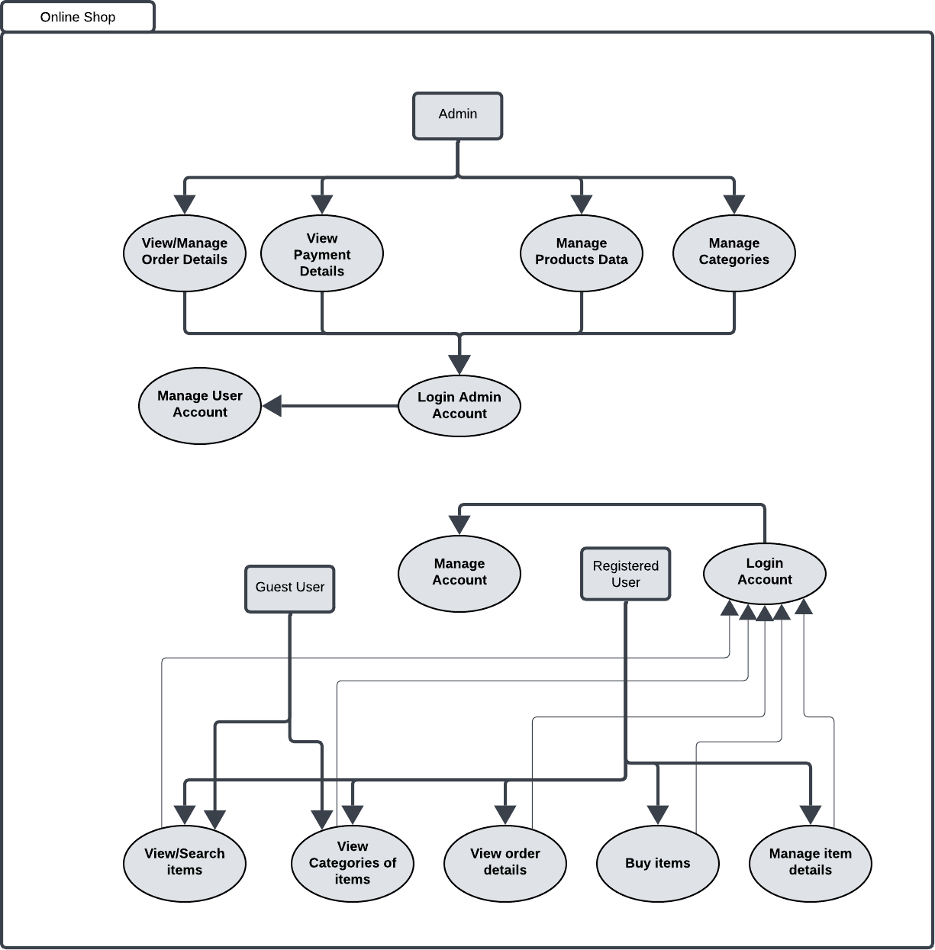

Figure4.1 System Architecture

Description
The system architecture diagram illustrates the functional flow and user roles within an e- commerce platform. It is divided into two main sections: Admin and Users (Guest and Registered). The Admin is responsible for managing the backend of the system and has access to features such as managing product data, viewing and managing order details, viewing payment information, managing user accounts, and organizing product categories. The admin must first log in through the admin login module to access these functionalities.
On the user side, there are two types of users: Guest Users and Registered Users. Guest users can interact with the system without creating an account. They are allowed to search and view items as well as browse different product categories. However, to perform actions such as buying items or viewing order details, users must register and log in to the system.
Registered Users have extended privileges. After logging into their accounts, they can manage their account information, view the details of their past orders, purchase items, and manage item- related activities like adding to cart or updating preferences. Both guest and registered users interact through the Manage Account and Login Account modules for account-related tasks.
Overall, this architecture supports a clear and structured interaction between different user roles, ensuring efficient control for administrators and a seamless shopping experience for customers.

Data Representation

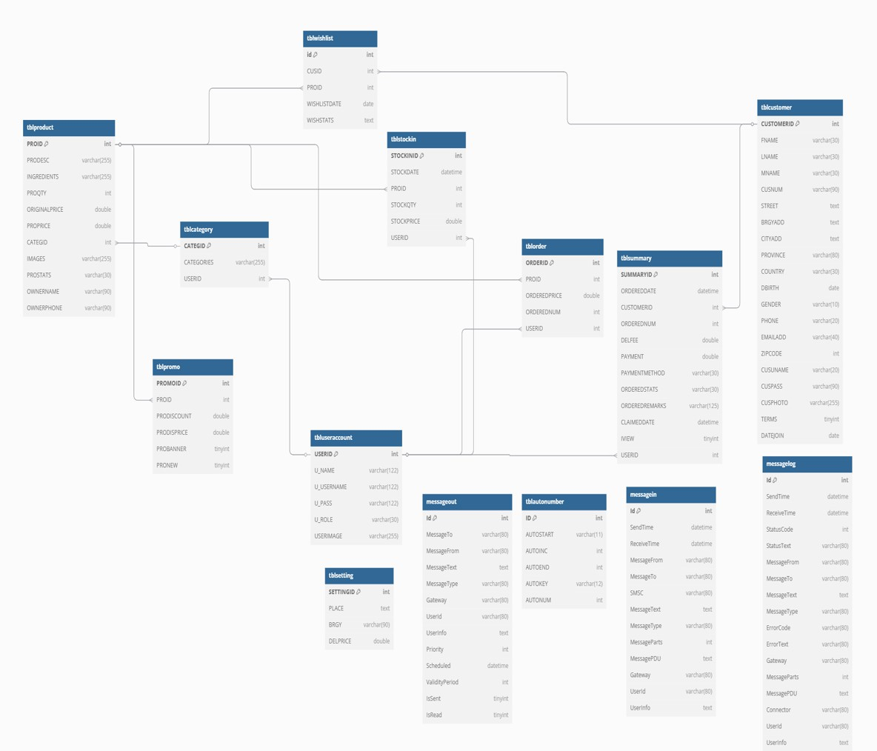
Figure4.2 Data Representation

Description
This e-commerce database system is designed to manage product listings, customer orders, inventory tracking, promotions, messaging, and user accounts. At the core is the tblproduct table, which stores details of products such as descriptions, ingredients, pricing, quantity, images, and ownership information. Each product is associated with a category defined in the tblcategory table, allowing products to be organized by type, and managed by users from tbluseraccount.

Customer information is handled in the tblcustomer table, capturing essential personal and contact details. When customers place orders, entries are created in the tblorder table, which records product IDs, quantities, prices, and associated user IDs. Each order is summarized in the tblsummary table, which includes payment information, order status, delivery fees, and remarks, linking both the customer and the user handling the order.
The tblstockin table manages incoming product stock, logging quantities and prices, and associating them with users. The system also supports promotions through the tblpromo table, which links to products and includes discounts and promotional flags. Customer preferences are captured in the tblwishlist table, showing saved products and their statuses.
Operational settings such as delivery prices by area are maintained in the tblsetting table. Messaging functionalities are supported through the messagein, messageout, and messagelog tables, allowing for internal and external communication tracking. Auto-generated numbers used across the system are controlled by the tblautonumber table.
Overall, this database schema provides a comprehensive backend structure for running and managing an online store, with emphasis on product management, customer handling, order processing, inventory control, user administration, and communication.

Process Flow Representation

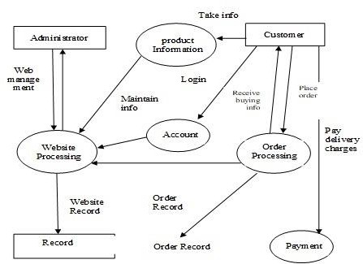

Figure4.3 Process flow Representation

Description
This diagram represents the workflow of an e-commerce website, highlighting the interaction between the Administrator, Customer, and the internal components like Product Information, Order Processing, Website Processing, Account, and Payment.
The process begins with the Administrator, who manages the website through the Website Processing module. This module handles all administrative tasks and ensures that the website content and structure are maintained. The administrator also updates Product Information, which is then made available to customers.
Customers interact with the system by first accessing product details. They can login and use the Account module to manage personal information. After selecting desired products, customers place orders which are handled by the Order Processing module. The order details, along with customer buying information, are passed on for processing.
Following the order placement, customers proceed to the Payment section, where they pay

delivery charges. All interactions – including account activities, order processing, and payment – are coordinated by the Website Processing system, which maintains website records and order records in the Record module for tracking and reporting purposes.
This diagram outlines a streamlined flow of how an e-commerce platform operates, ensuring coordination between users and system components for efficient online shopping and management.

Design Models
Below are the detailed design models for the system.

Class Diagram
The class diagram shows the structure of the system by illustrating the system's classes, their attributes, methods, and the relationships among objects.
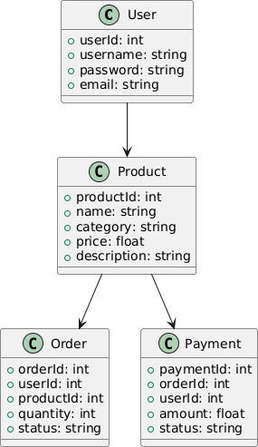

Figure4.4.1 Class diagram

Description
This is a class diagram representing the structure of a simple e-commerce system. It consists of five main classes: User, Product, Order, and Payment. The User class holds basic information about users, such as userId, username, password, and email. The Product class contains details about the items available for purchase, including productId, name, category, price, and description. Each product is associated with a user, indicating which user listed the product. The Order class stores information about customer orders, including orderId, userId, productId, quantity, and status. It links both the User and Product classes to show which user placed an order for which product and in what quantity. Finally, the Payment class records payment transactions with attributes such as paymentId, orderId, userId, amount, and status, linking payments back to specific orders and users. This diagram provides a clear overview of the relationships and data flow within the system.

Sequence Diagram

The sequence diagram shows how objects interact in a particular scenario of the system. They are a popular dynamic modeling solution in UML because they specifically focus on lifelines, or the processes and objects that live simultaneously, and the messages exchanged between them to perform a function before the lifeline ends.
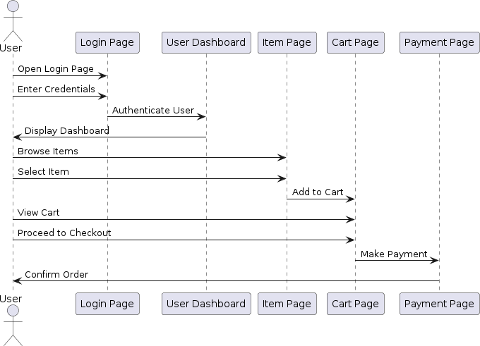

Figure4.4.2 Sequence Diagram

Description
The sequence diagram depicts the flow of interactions between a user and an e-commerce application during a typical online purchase. The user begins by opening the login page and entering their credentials, which triggers authentication by the system. Upon successful authentication, the user is redirected to the dashboard, where they can browse items. Selecting an item leads the user to the item page, where they can add the item to their cart. After viewing their cart, the user can proceed to checkout, which navigates them to the payment page. On the payment page, the user makes the payment. The system confirms the order, completing the purchase process.

State Transition Diagram
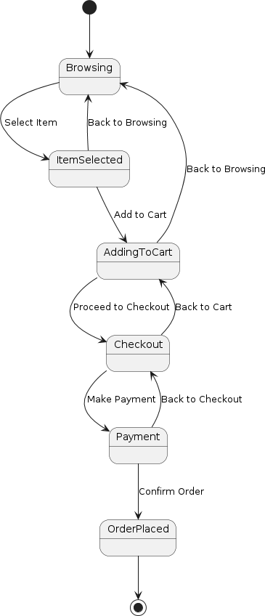
This diagram will show the transitions between different states of an item in the "Online Grocery Delivery App" system.

Figure4.4.3 Sequence Diagram

Data Flow Diagram
A Data Flow Diagram (DFD) is used to represent the flow of data within the system. We'll create a level 0 DFD for a high-level overview and a level 1 DFD for a more detailed view of the user registration and item purchasing processes.
Level 0 DFD

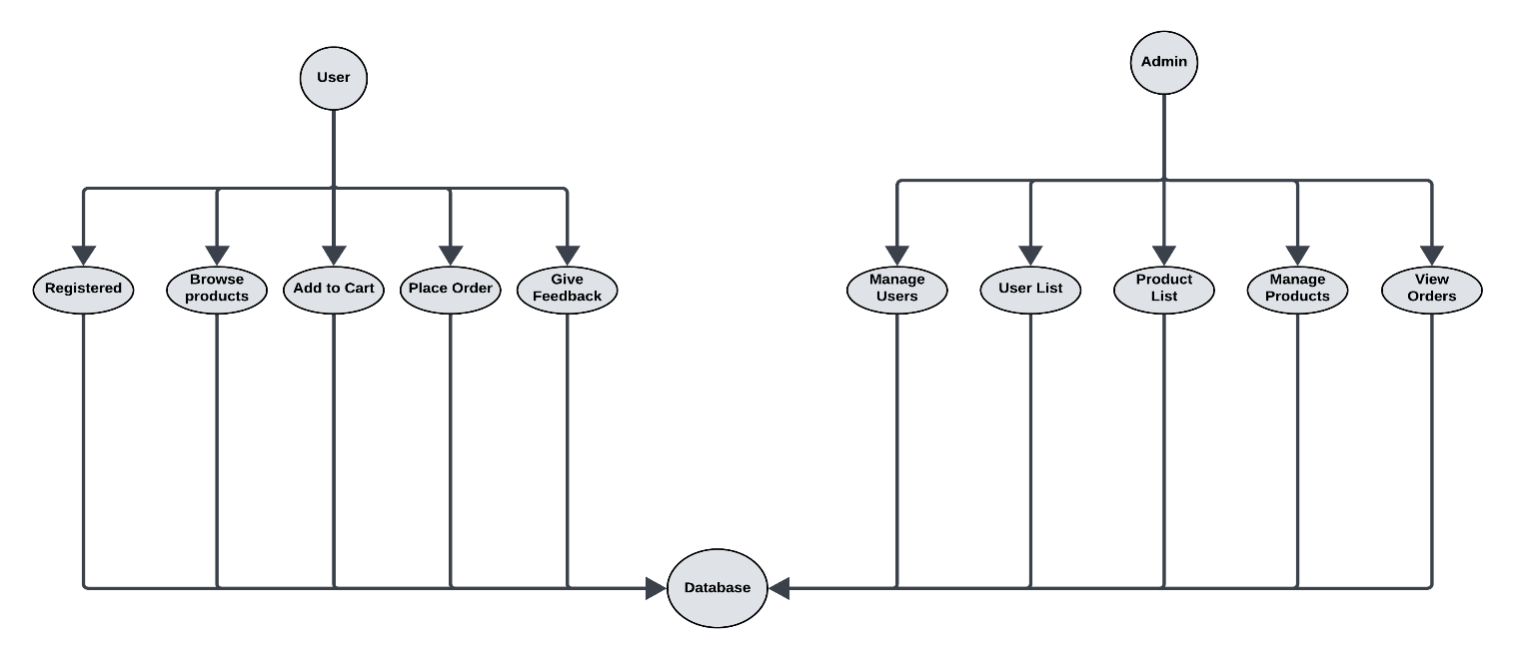
Figure4.4.3 Dataflow Diagram Level 1

Description

This diagram is a level 0 dataflow diagram of an online shopping system. It depicts the overall system flow, focusing on the main actors and their interactions with the system.
      - User: The user can browse items and register/login to the system. After logging in, they can add items to their cart and make payment.
      - Admin: The admin has the ability to manage products. They can also view reports about the system’s performance.
      - Database: The database is the central component where all the system data is stored and accessed. Both the user and admin interact with the database, with the user storing their information and shopping cart details, and the admin managing product information and accessing system reports.
This level 0 DFD provides a high-level overview of the online shopping system, illustrating the core functionalities and data flow between the key actors and the database.

Level 1 DFD (User Registration and Item Purchasing)
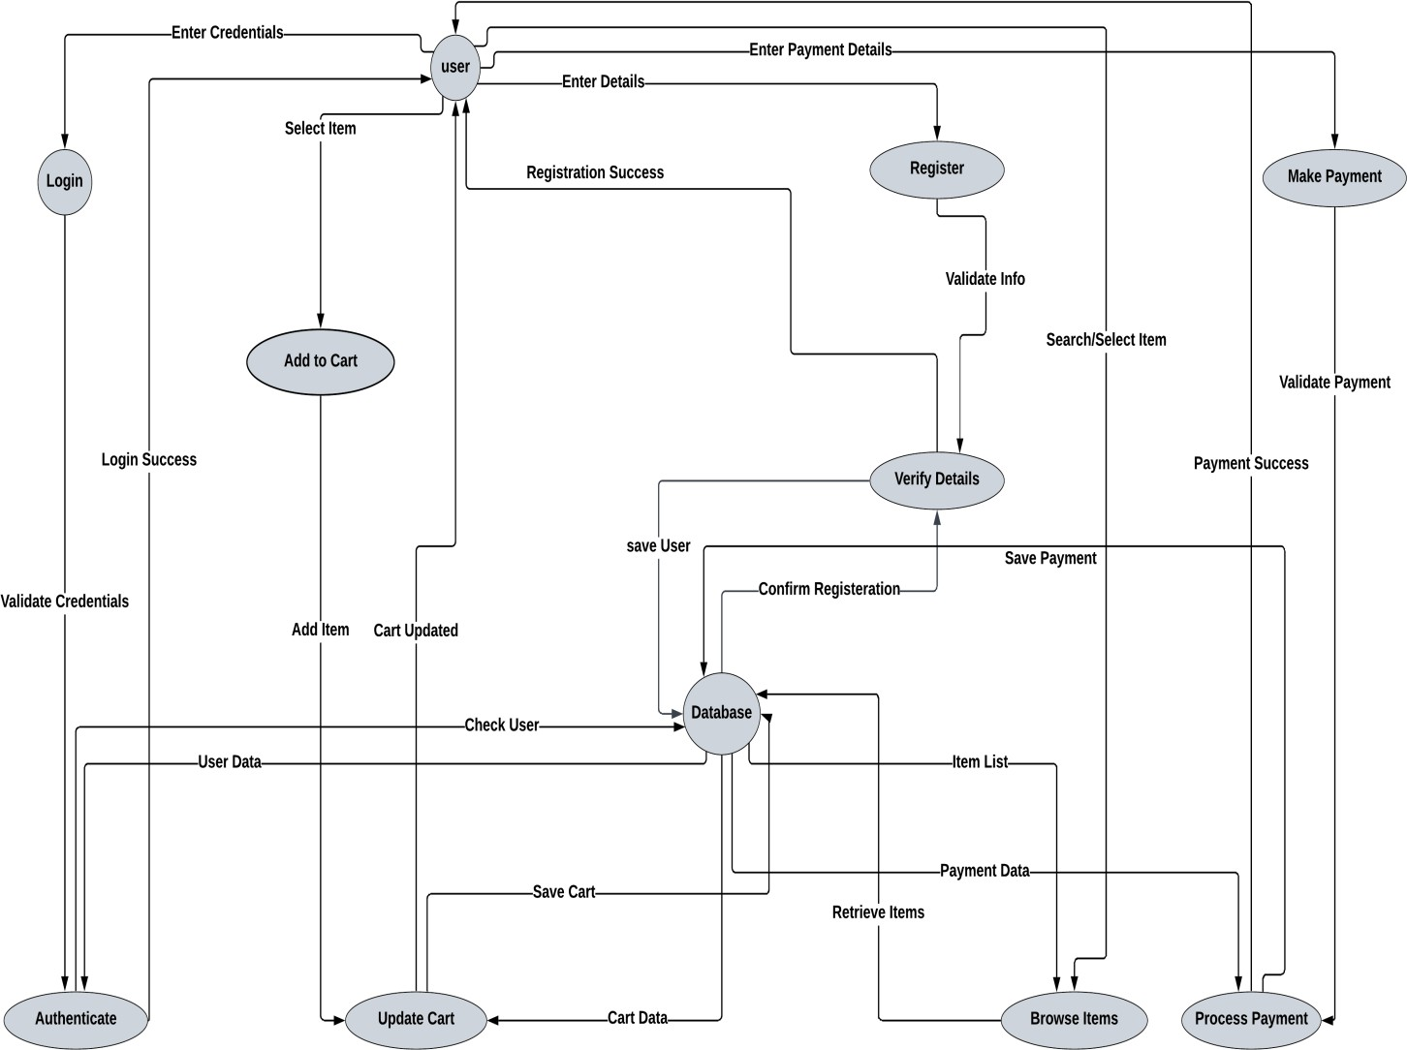

Figure4.4.3 Dataflow Diagram Level 1

Description
The diagram depicts the data flow of an online shopping system. The user begins by logging in or registering. After successful authentication, they can browse items and select those they want to purchase. Items are added to the cart, which is then updated. Once the user has completed their selection, they proceed to the payment section, where they enter payment details and make a payment. The system validates the payment information and processes the transaction. Finally, the user receives confirmation of their order. The diagram shows the interactions between the user, the system, and the database, which stores user information, product details, and order data. The database is accessed by the system to retrieve item data and store user and order information. The system handles user input, validates data, updates the cart, and processes payments.

Implementation

Technologies Used

HTML
HTML or Hypertext Mark-up Language is a standard mark-up language for web application development. Web browsers read HTML files and convert them to graphical items on viewport. HTML allows images and objects to be embedded and can be used to create interactive forms. It provides a means to create structured documents by denoting structural semantics for text such as headings, paragraphs, lists, links, quotes and other items.

JavaScript
JavaScript provides the behavioral of the web elements included in HTML. It also provides data binding for the HTML elements. Also, JavaScript provides a way to connect with database and fetch the data real-time.

CSS
CSS or Cascade Style Sheet is a way to create a look to HTML elements. This makes the page more interactive as compared to plain HTML elements. Along with this bootstrap framework also provide an effective way for designing.

PHP
PHP is a general-purpose scripting language geared toward web development. PHP is an acronym for PHP: Hypertext Pre-processor. It is widely using open-source scripting language. PHP scripts are executed on server

Algorithm

Here we summarize the key algorithms for the system.

User Login

function login (username, password) retrieve user data from database
if username and password match return success

else

return failure
- Add Item to Cart

function addItemToCart (userId, itemId, quantity) retrieve cart for userId
if item already in cart update quantity
else
add item to cart return updated cart
- Process Payment
function processPayment (orderId, paymentDetails) validate paymentDetails
if valid
update order status to 'Paid' create payment record return payment success
else
return payment failure

External APIs

None utilized; all functionalities implemented using PHP and MySQL.
  - User Interface

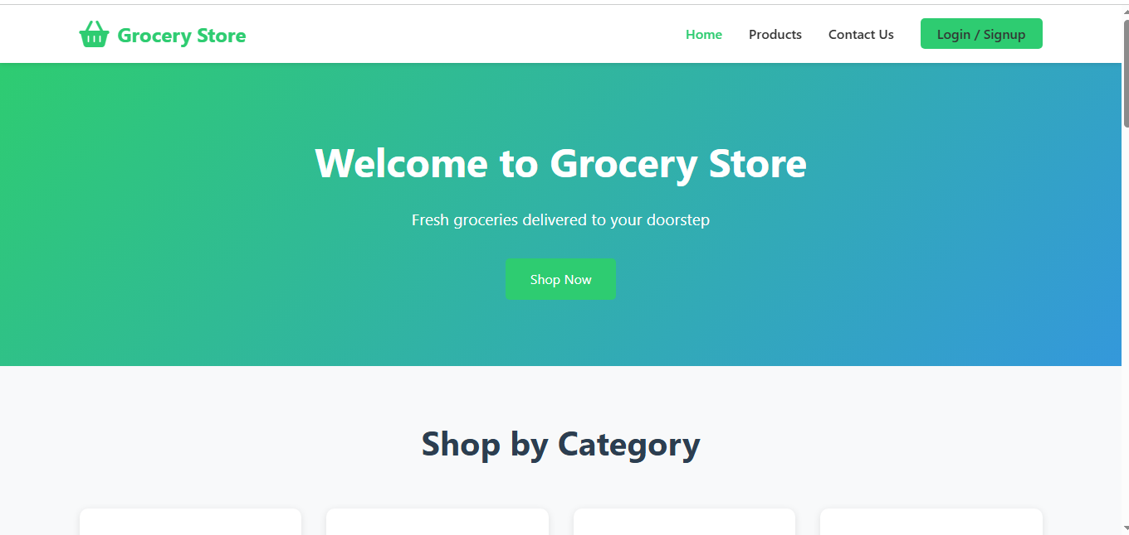

Products
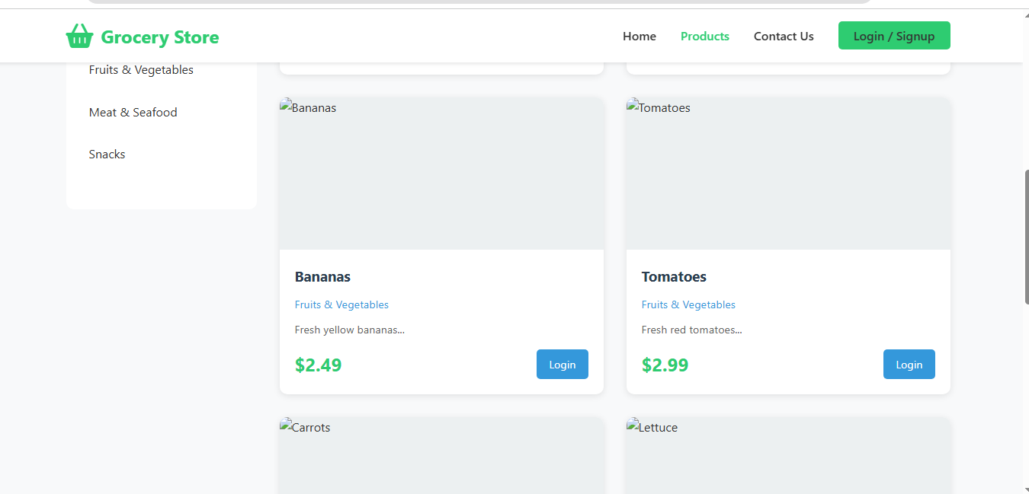

Contact Us
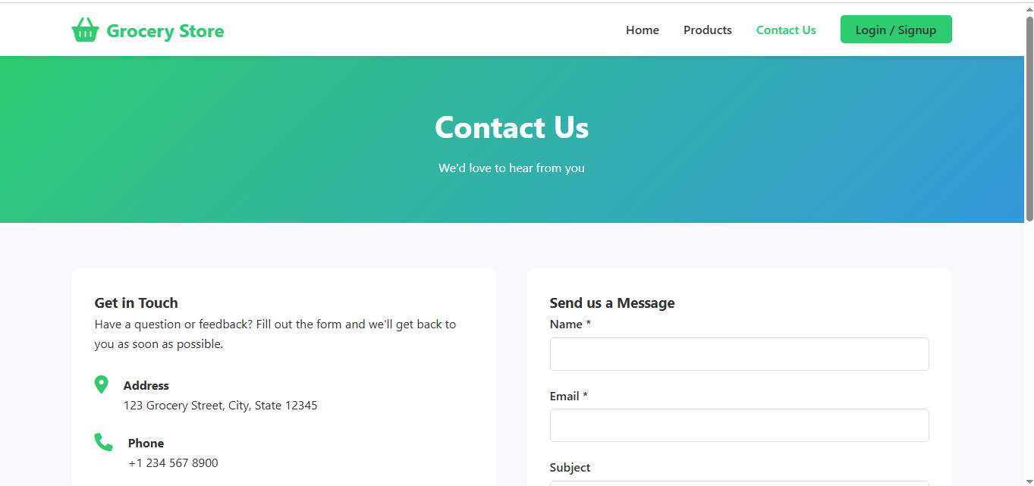

User Pannel



Login Page

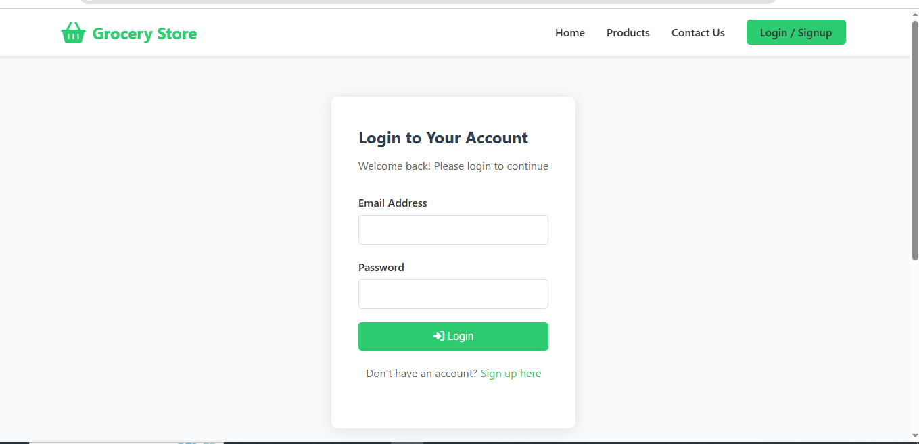

Testing and Evaluation
This chapter may include the following sections. (Students are required to perform the testing both manually and automatedly).

Manual Testing

System testing
Once the system has been successfully developed, testing has to be performed to ensure that the system working as intended. This is also to check that the system meets the requirements stated earlier. Besides that, system testing will help in finding the errors that may be hidden from the user. The testing must be completed before it is being deploy for user to use.

Unit Testing
Validations were made for each single module and each module was tested independently. Maximum error detection was made at this stage. Proper flow of inbound and out bound information was made.

Integration Testing
Integration testing was carried out to check whether each module works properly with the integrated module. Different inputs were given to the secondary module from the primary, to check whether it works properly for each input which comes from the higher level. Both Bottom up and Top-down integration tests were carried out.

Functionality Testing
All functions in the application, database connection, forms used to enter data for submission, editing, getting, or deleting information from users were tested. Developers performed the test of the website. Some functionality requirements were tested during the test.

Table 6.1.1: Test Cases for Login and Registration Page:

TEST ID | DESCRIPTION | INPUT DATA | EXPECTED RESULT | ACTUAL RESULT | STATUS
TC 1 | Verify that a new user can successfully register on the website. | Valid name, email, password  , and address. | User should be successfully registered and redirected to the homepage. | User is successfully registered and redirected to the homepage. | PASS
TC 2 | Verify that the user cannot register with invalid or incomplete information. | Incomple te or invalid name, email, password  , or address. | The user should be prompted to fill in all required fields before proceeding. | The user is prompted to fill in all required fields before proceeding. | PASS
TC 3 | The user is on the login page and has a registered account. | Valid email and password  . | User should be successfully logged in and redirected to the homepage. | User is successfully logged in and redirected to the homepage. | PASS
TC 4 | Verify that a user cannot login with invalid or incorrect login credentials. | Invalid or incorrect email or password  . | The user should be prompted to enter a valid email and password. | The user is prompted to enter a valid email and password. | PASS

Table 6.1.2: Test Cases for displaying details of the product:

TEST ID | DESCRIPTION | INPUT DATA | EXPECTED RESULT | ACTUAL RESULT | STATU S
TC 1 | Verify that the product details are displayed correctly on the product page. | Valid product information. | The website should display the product details correctly. | The website displays the product details correctly. | PASS
TC 2 | Verify that the website handles invalid product details request correctly. | Invalid product ID or other incorrect product information. | The website should display a message indicating that the product details could not be found. | The website displays a message indicating that the product details could not be found. | PASS
TC 3 | Verify that the product reviews are displayed correctly on the product page. | Valid product reviews. | The website should display the product reviews correctly. | The website displays the product reviews correctly. | PASS
TC 4 | Verify that the product rating system works correctly. | Valid rating selection. | The website should update the product rating accordingly and display the new rating on the product page. | The website updates the product rating accordingly and displays the new rating on the product page. | PASS
TC 5 | Verify that the user can add the product to the cart. | Valid product and cart information. | The website should add the product to the cart and display the cart page correctly. | The website adds the product to the cart and displays the cart page correctly. | PASS

Table 6.1.3: Test Cases for adding a product to the cart:

TEST ID | DESCRIPTION | INPUT DATA | EXPECTED RESULT | ACTUAL RESULT | STATUS
TC 1 | Verify that the | Valid product and | The website | The website adds the | PASS
 | product is | cart information. | should add | product to the cart
 | successfully |  | the product to | and displays the cart
 | added to the cart. |  | the cart and | page correctly.
 |  |  | display the
 |  |  | cart page
 |  |  | correctly.
TC 2 | Verify that the | Invalid product | The website | The website displays | PASS
 | website handles | ID or other | should | a message indicating
 | an invalid product | incorrect product | display a | that the product
 | addition to cart | information. | message | could not be added
 | request correctly. |  | indicating | to the cart.
 |  |  | that the
 |  |  | product could
 |  |  | not be added
 |  |  | to the cart.
TC 3 | Verify that the | Verify that the | Valid product |  | PASS
 | cart quantity is | cart quantity is | and cart
 | updated correctly | updated correctly. | information.
 | when adding
 | products to the
 | cart.
TC 4 | Verify that | Valid product and | The website | The website adds all | PASS
 | multiple products | cart information | should add | the products to the
 | can be added to | for multiple | all the | cart and displays the
 | the cart. | products. | products to | cart page correctly.
 |  |  | the cart and
 |  |  | display the
 |  |  | cart page
 |  |  | correctly.

Table 6.1.4: Test Cases for checkout:

TEST ID | DESCRIPTION | INPUT DATA | EXPECTED RESULT | ACTUAL RESULT | STATUS
TC 1 | Verify that the user can successfully checkout with an existing account. | Valid shipping and payment information. | The website should process the order and display a confirmation page. | The website processes the order and displays a confirmation page. | PASS
TC 2 | Verify that the website handles invalid payment information correctly during checkout. | Invalid payment information. | The website should display an error message indicating that the payment information is invalid and prompt the user to correct it. | The website displays an error message indicating that the payment information is invalid and prompts the  user to correct it. | PASS
TC 3 | Verify that the website handles attempting to checkout with an empty cart correctly. | Empty cart. | The website should display an error message indicating that the cart is empty and prompt the user to add items before proceeding. | The website displays an error message indicating that the cart is empty and prompts the user to add items before proceeding. | PASS
TC 4 | Verify that the user receives an order confirmation after completing checkout. | Verify that an order confirmatio n page or email is displayed. | The website should display an order confirmation page or email with the details of the order and any relevant information (e.g. estimated delivery date). | The website displays an order confirmation page or email with the details of the order and any relevant information. | PASS

Automated Testing:
Table 6.2.1:

Tool/Method Name | Description | Applied On | Expected Results | Actual Results | Status
Browser | Inspect and debug UI and JavaScript functionality. | Login Form, Registration Form, Product Page | Forms and buttons should function as  expected without errors. | All UI elements worked as expected. | Pass
Form Validation Tests | Check client- side form validations. | All forms (Login, Registration, Checkout) | Forms should validate data and show error messages for  invalid input. | Validations worked perfectly. | Pass
Database Query Testing | Execute SQL queries to verify database  behavior. | MySQL  Database (User Data, Products) | Insert, update, and delete operations should work  without issues. | Queries executed successfully. | Pass

Conclusion and Future Work
This chapter concludes the project and highlights future work.

Conclusion
The Online Grocery Delivery App project offers a complete e-commerce solution that enables users to browse, search, and purchase products easily through a user-friendly interface. It simplifies online shopping by providing essential features like product management, cart functionality, and secure order placement. This project lays the foundation for future enhancements like digital payments and real-time order tracking, ensuring a scalable and practical system for modern online retail needs.

Future Work
- Introduce a mobile application for greater accessibility.
- Implement AI for personalized product recommendations.
- Expand payment options to include digital wallets.

References

- Altexsoft.com, “Functional & Non-Functional Requirements: Specification and Types”
- Wikipedia.org, “Ecommerce Overview”
- Geeksforgeeks.org, “A Computer Science Portal for Geeks”
- Luidchart.com, “Diagrams”

